JOB DESCRIPTION – ACCOUNTS PAYABLE ASSISTANT

Job Title: Accounts Payable Assistant
Reporting to: Finance Manager

About Us:

Our purpose is the decoding of milk data and building robust insights. The company and its people provide the highest quality recording, testing, health and fertility services & products for dairy animals, supporting farmers and the dairy industry to make sustainable production possible as well as working with milk buyers and retailers to constantly improve the quality of the milk we drink.

Our people are at the core of our business, their passion for what NMR provides the dairy agricultural industry is something we pride ourselves on. Ensuring collaboration and a can-do attitude every day in behaviours ensures a motivated team of people sharing their expertise with each other and our stakeholders. Our values enable us to behave in a professional way and create a positive trusted environment to work within.

The Role:

Reporting to the Finance Manager, you will provide crucial support to the finance team, focusing your time ensuring all supplier invoices are processed and paid in a timely manner and that the creditors ledger is complete.

Key Skills:

- Flexible and team player, builds relationships based on respect and care
- Experience of purchase ledger with strong attention to detail
- Well organised with good IT skills including Excel
- Understanding of VAT rules in regard to Input tax
- Experience of Dynamics365 would be an advantage

Key Responsibilities:

- Log, code and send purchase invoices for approval
- Process approved purchase invoices & chase those awaiting return from budget holder
- Processing staff cash and credit card expenses
- Processing payment runs and ad-hoc payments in accordance with agreed credit terms
- Opening new vendor accounts
- Supplier statement reconciliations
- Monthly reporting on the creditors ledger
- Adhoc queries from other depts
- Implementation of new processes & continuous improvement

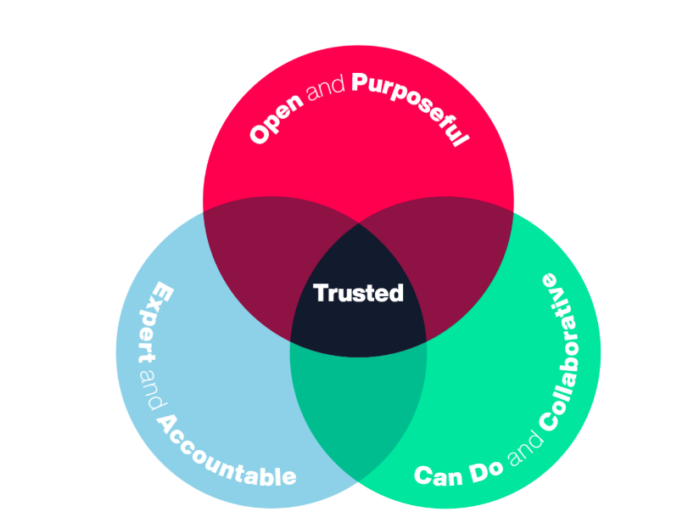
Our Values

